IRO 2026 Creative Category: Gold Medal Roadmap
Oct 19, 2026 · @Nordin

Goal and key facts
Goal: a gold medal in the IRO 2026 Creative Category (Austria) with an intangible-heritage storyteller robot. Half the score is creativity, so the plan puts story and idea practice on the same level as the robot build.
What | Detail
Theme | Cultural Heritage Service Robots: help people experience, understand and protect cultural heritage
Team | 1 to 3 members, all work done on-site
Sub-topic | Revealed on competition day 1
Production plan | 2 hours, written on day 1 before lunch
Build time | Maximum 4 hours across 2 days
Presentation | 3 minutes + 2 minutes Q&A
Space | One table, about 180 cm x 60 cm
Late penalty | -1 point per 5 minutes late; 30 minutes late = disqualified
Score weights (100 points): Creativity 50 · Technical 20 · Completion 10 · Presentation 20. Topic Understanding is marked O/X across items, so staying on the sub-topic is essential.
Rules that shape this plan:
- All hardware and software must be built on-site, except the controller (rule 2.3).
- No notes, manuals, photos or internet; phone SIMs removed (rules 6.1 to 6.3). Everything runs offline and is practised from memory.
- The robot must match the production plan (rule 2.5.1). Only plan what you can build in 4 hours.
- Only staff and referees may help; coaches and parents may not (rule 6.5).
- Tiebreak order: technical skill, then creativity, then completeness.

Project concept
The robot is a living storyteller for intangible heritage: it notices a visitor, turns to them, talks in their language, recognises heritage objects and performs a tradition with its arm.
Core story: "When the last storyteller is gone, the story dies. Our robot keeps the storyteller alive, in any language, for anyone."
Part | Heritage job | Rubric item it feeds
Jetson Orin Nano (ROS 2 Humble) | Runs everything offline: LLM, speech, vision, navigation | Technical Difficulty, Integration
Mic array (Cytron) | Hears the visitor and finds their direction, so the robot turns to them | Sensor / Input
Offline LLM + speech-to-text + text-to-speech | Tells heritage stories and answers questions in BM, English and German | Creativity, Social Contribution
SO-ARM101 + global-shutter camera | Performs heritage (wayang kulit puppet, batik or silat motion) and looks at objects up close | Motor / Output, Creativity
Few-shot object recognition (+ YOLO-World) | Learns a heritage object from a short video and tells its story | Technical Difficulty, Demo
Depth camera (low on body) | Sees children and wheelchair users clearly, so the robot adapts | Social Contribution (accessibility)
RPLidar | Detects approaching visitors and keeps the robot out of artifact no-go zones | Sensor / Input, Protect heritage
TETRIX + TorqueNADO + mecanum | Safe movement and turning toward visitors | Motor / Output
SCD30 (optional) | Warns when CO2, temperature or humidity are bad for artifacts | Protect heritage
Screen with RViz dashboard | Shows judges what the robot sees, hears and thinks | Demo, Q&A
Why it fits the theme: experience (the arm performs), understand (stories and Q&A), protect (no-go zones and room monitoring), and inclusive (languages and accessibility).

Roadmap
Five two-week phases take the robot from a safe base to a frozen, practised entry; dates assume a late-December competition.
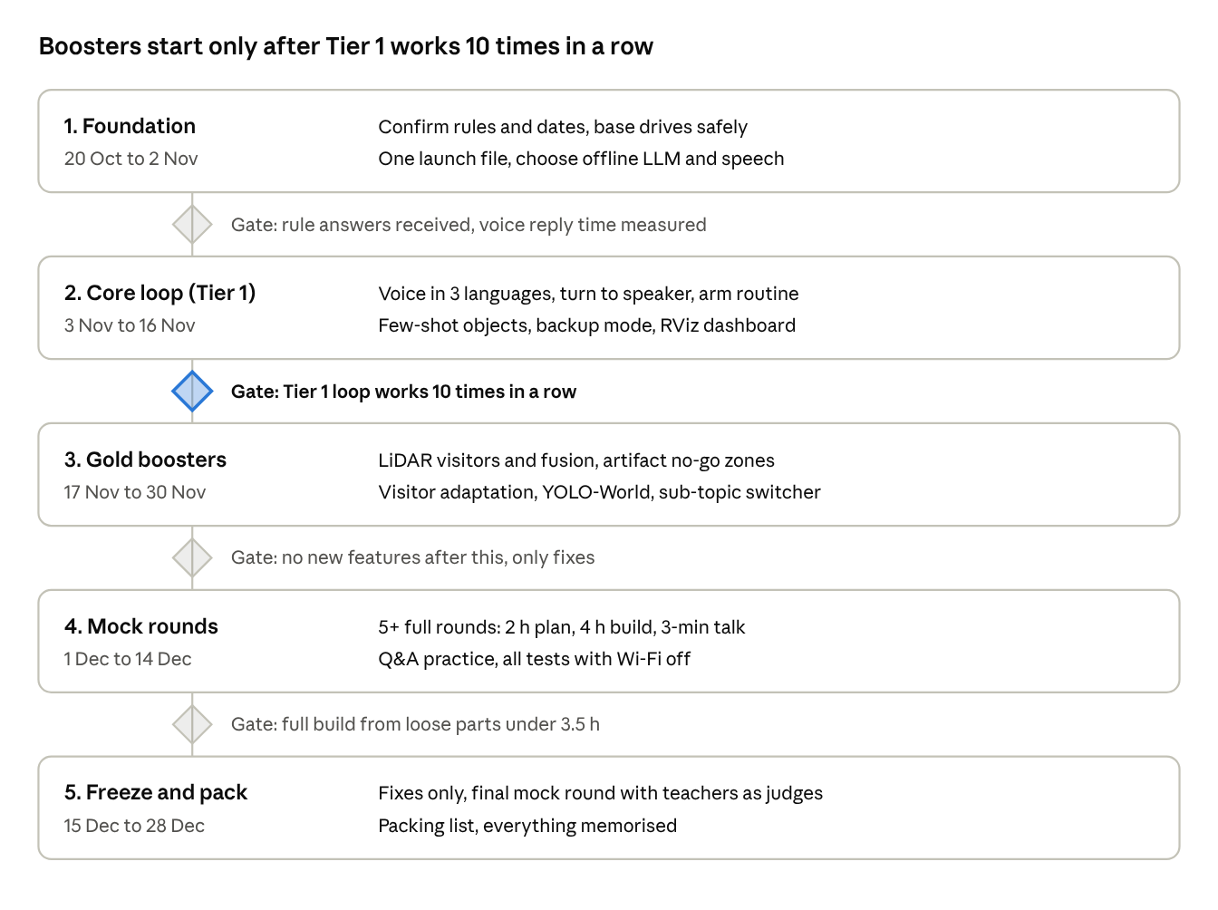
roadmap · 5 phases, 4 gates
No phase starts until the gate above it is passed. The gate after the core loop matters most: boosters are only added to a Tier 1 loop that never fails. Detailed tasks for each phase are in the weekly checklist below.

Feature priority
Build Tier 1 until it never fails, then add Tier 2 one feature at a time. Tier 3 is the practice that turns a good robot into a gold one.
Tier 1 — must-have (build first, in this order)
- Safe mecanum movement with an emergency stop
- Offline voice loop: speech-to-text, LLM, text-to-speech in BM, English and German, reply in under about 3 seconds
- Turn to the speaker using the mic array direction
- Arm heritage performance (one gesture or puppet routine that always works)
- Few-shot object recognition: film an object, robot names it and tells its story
- Backup mode: a button that plays ready-made answers if the LLM fails
- RViz dashboard showing what the robot sees, hears and thinks
Tier 2 — gold boosters (only after Tier 1 is solid)
- LiDAR visitor detection (new person approaching from up to 5 m)
- Sensor fusion: LiDAR spots, camera confirms, mic matches direction, then the robot turns
- LiDAR artifact no-go zones with the live map on screen
- Visitor adaptation: child or wheelchair user detected, robot adjusts speech and position
- YOLO-World finds the object, few-shot model identifies which heritage item it is
- Artifact room monitor (SCD30)
- Sub-topic switcher: change the LLM's role and knowledge in about 5 minutes
Tier 3 — not features, but needed for gold
- Full build from loose parts in under 3.5 hours
- Production plan template memorised, finished in 1.5 hours
- 3-minute presentation script and a Q&A practice list
- Everything tested with Wi-Fi off

Rubric coverage
Every criterion has a planned way to earn full marks; the hardware already covers the technical items, so the gaps are practice and story.
Criterion | Points | How we earn full marks
Production Plan Document | 10 | Fixed 7-part template (below), neat system diagram, finished in 1.5 h
Creative / Realistic Solution | 15 | Arm performs heritage + live object learning; only promise what works
Social Contribution | 15 | Keeps intangible heritage alive; accessibility (children, wheelchair users, elderly); BM, English, German
Storytelling / Theme Delivery | 10 | One clear story: problem, robot, live proof, impact
Technical Difficulty | 5 | Offline LLM, vision and LiDAR on the Jetson with ROS 2
Sensor / Input | 5 | Mic, depth camera, arm camera, LiDAR, each with one named job
Motor / Output | 5 | Mecanum drive, arm gestures, voice, screen
Feasibility | 5 | Everything in the plan is shown working on the table
System Integration | 10 | Sensor fusion in one loop; problems solved during the build are explained
Demonstration | 10 | Reliable opener + full loop; backup mode ready
Q&A | 10 | Every member can explain every part and every design choice
Topic Understanding | O/X | Each feature is linked out loud to the day's sub-topic
Production plan template (memorise):
- Problem: what heritage is at risk and why
- Who it helps: visitors, children, elderly, disabled people, museums
- Solution in one sentence
- Features, each linked to the problem
- System diagram: sensors, Jetson, outputs
- How it works, step by step
- Impact on society and culture

Competition-day plan
Aim to finish the plan in 1.5 of 2 hours and the build in 3.5 of 4 hours, so there is always a 30-minute safety margin.
Day 1 morning — production plan (2 h)
- First 10 min: read the sub-topic, agree which features fit it, change the LLM's role to match
- Next 60 min: fill the 7-part template, one member per section
- Next 20 min: draw the system diagram and check the plan matches what you can build
- Last 30 min: spare time for checking and neatness
Day 1 afternoon + Day 2 — build (4 h max)
- Assemble the base and wiring first, test motors
- Mount the LiDAR, cameras, mic array, then the arm; calibrate the arm
- Launch everything with one ROS 2 launch file, check each topic
- Film the heritage objects under the venue's lights for the few-shot model
- Run the full demo loop 3 times; switch to backup mode if anything fails
- Clean the table (rule 7.3) and submit on time
Presentation (3 min + 2 min Q&A)
Time | Part | What happens
0:00–0:25 | Wow opener | Robot greets the judges by itself, turns, speaks, arm gestures
0:25–1:05 | Problem and story | Why intangible heritage is disappearing, who we help
1:05–2:25 | Full demo | Object learning, no-go zones on screen, visitor adaptation
2:25–3:00 | Impact and closing line | Social impact, the closing sentence
3:00–5:00 | Q&A | Each member answers on their part of the robot

Risks and open questions
The biggest risks are time on-site and a demo that fails once; each has a backup.
Risk | Effect | Backup
Build runs over 4 hours | Point deductions, or disqualified at 30 min late | Mock builds until under 3.5 h; drop Tier 2 features first
LLM reply is slow or freezes | Awkward silence in the demo | Smaller model, shorter replies, backup-mode button
Noisy hall confuses the mic | Robot turns the wrong way | Mic for rough turn only; camera centres the person
LiDAR flags table legs or chairs | False visitors | Learn the empty room at start; only moving objects count
Venue lighting fools object recognition | Wrong object named | Film objects at the venue; "I'm not sure" threshold
Arm calibration goes wrong on-site | No heritage performance | Practise calibration in every mock build
Battery runs low | Robot dies mid-demo | Full charge before the slot; test a full-day run
Judges rule pre-written code or a trained model breaks rule 2.3 | Excluded from awards | Get a written answer first; practise writing core code from memory
Open questions to confirm:
- ☐ Exact IRO 2026 competition dates and venue in Austria
- ☐ Ask the IRO Secretariat (through the coach, in writing): may code or trained models be prepared before the event, or must all software be written on-site?
- ☐ Does the SO-ARM101 count as a pre-made part? Must it arrive unassembled?
- ☐ Does the TETRIX PRIZM count as a controller alongside the Jetson?
- ☐ Is a monitor or screen allowed on the table for the dashboard?

Weekly checklist
Weeks count from 20 Oct 2026 and assume the competition is around the end of December; shift them once the date is confirmed.
Weeks 1–2 (20 Oct – 2 Nov): Foundation
- ☐ Confirm competition dates and send the rule questions to the Secretariat
- ☐ Assign owners: hardware, software, story and presentation
- ☐ Mecanum base drives safely with an emergency stop
- ☐ One ROS 2 Humble launch file starts the LiDAR, cameras and motors
- ☐ Pick the offline LLM, speech-to-text and text-to-speech; measure reply time on the Jetson
- ☐ Choose the heritage focus and 3–4 heritage objects
Weeks 3–4 (3 – 16 Nov): Core loop (Tier 1)
- ☐ Voice loop works in BM, English and German, reply under about 3 s
- ☐ Robot turns to the speaker using the mic direction
- ☐ Arm performs one heritage routine reliably
- ☐ Few-shot recognition learns a new object from a short video
- ☐ Backup-mode button works
- ☐ RViz dashboard shows camera, map and robot state
- ☐ Gate: the Tier 1 loop works 10 times in a row
Weeks 5–6 (17 – 30 Nov): Gold boosters (Tier 2)
- ☐ LiDAR visitor detection and sensor fusion
- ☐ Artifact no-go zones on the live map
- ☐ Visitor adaptation for children and wheelchair users
- ☐ YOLO-World + few-shot pipeline
- ☐ SCD30 room monitor (optional)
- ☐ Sub-topic switcher, tested with 5 practice sub-topics
Weeks 7–8 (1 – 14 Dec): Mock rounds
- ☐ At least 5 full mock rounds: random sub-topic, 2 h plan, 4 h build, 3-min presentation
- ☐ Full build from loose parts in under 3.5 h
- ☐ Presentation script practised 20+ times
- ☐ Q&A practice list; every member answers on every part
- ☐ All tests run with Wi-Fi off
Weeks 9–10 (15 – 28 Dec): Freeze and pack
- ☐ Feature freeze: no new features, only fixes
- ☐ Final mock round in front of teachers as judges
- ☐ Packing list: spare parts, cables, batteries, chargers, plug adapters for Austria
- ☐ Everything needed is memorised, since no notes are allowed

